IoT Analytics
Wen-Han Hu (whu24)
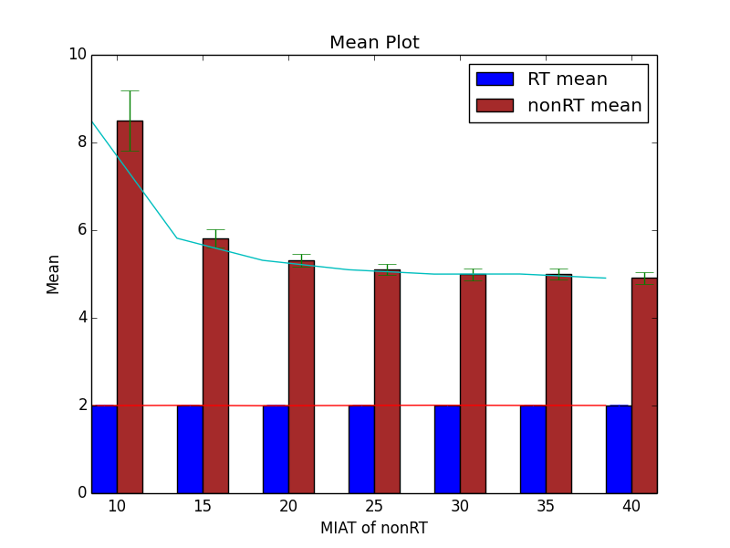

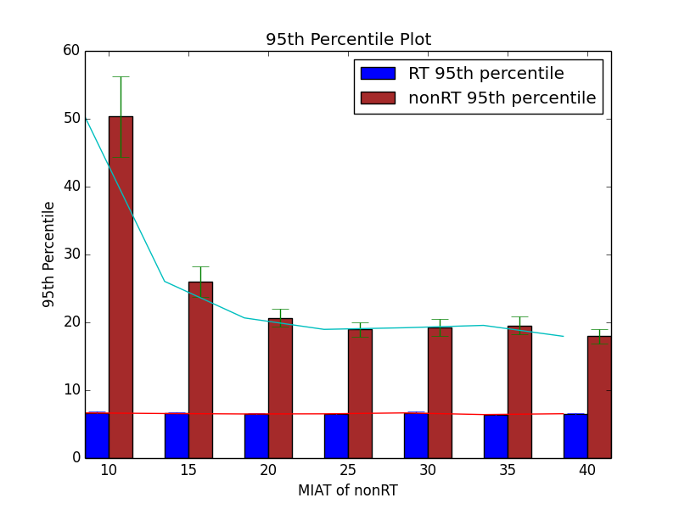

With the results above, we can find that the RT the response time always will be very close to the mean service time that is because the mean service time of an RT message is much shorter than the mean inter-arrival time of RT messages. The RT message won’t stay in queue, instead, all the RT will be executed right after arrival.

In addition, with increment of mean inter-arrival time of nonRT messages, the mean and 95th percentile of nonRT decrease since the queue won’t be too long because the interval increase. The decrease will remain stable after the mean inter-arrival time of nonRT is greater than 20 since the response time cannot be shorter than mean service time of nonRT messages. In other words, if we would like to improve the response time of nonRT messages, it won’t affect much when the response time close to the mean service time. The 95th percentile value has similar behavior as mean value. However, even though the value won’t change much, the range of confidence interval actually smaller. That is because the results is getting close to the mean or 95th percentile.

